Fluid Science DI Water Re-order Form
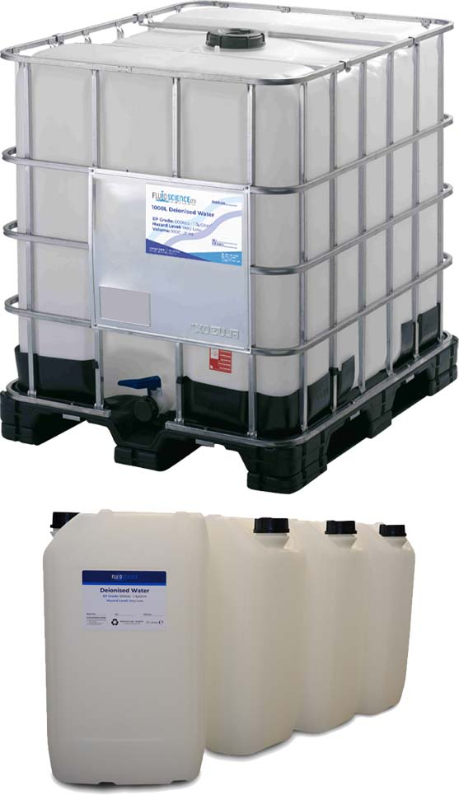
Grade (Standard/Ultra-Pure):

IBC or 25L Drums:

Volume:

Industry:

Forklift (Yes/No):

Company Name:

Delivery Address:

Point of Contact
Name:

Email:

Phone number:

Payment Method*:
*30/60-day credit accounts are available on request.

Submit this form to your delegated Fluid Science representatives’ email or send to sales@fluidscienceltd.com
A digital copy of this form can be found at the bottom of the Deionised Water Pages or here:
https://www.fluidscienceltd.com/wp-content/uploads/Fluid-Science-DI-Water-Re-order-Form.docx

